The working environment
Introduction to Module 2

All new entrants to the passenger transport sector will undergo a thorough induction process. During this time they will receive company information covering Health and Safety, and policies and procedures specific to their own employment setting. It is expected that workers can access and understand this information, not only during the induction period, but throughout their employment as specific needs arise and in order to update their knowledge. In this module, teachers and learners will look at a variety of strategies for reading and understanding a wide range of written information, as well as thinking about working with others and receiving training. It includes:
- accessing information in a company manual
- reading health and safety signs
- understanding health and safety information
- working with others
- responding to training
- understanding shifts and rosters.
The information used for this module is generic to a range of passenger transport settings. It is important that learners are encouraged to apply the skills and strategies developed here to the context of their own workplace setting and to their own company policies and procedures. Content can also be customised using the Word version of the materials.

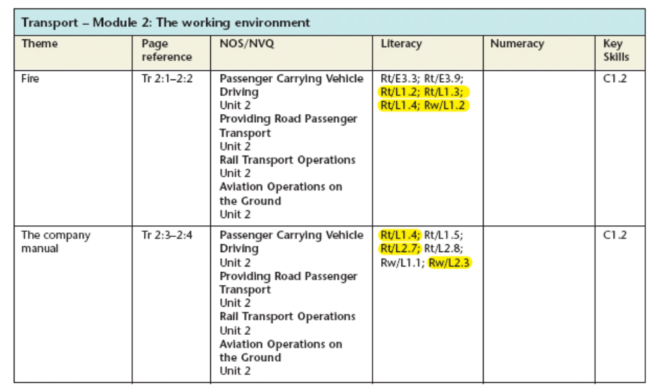
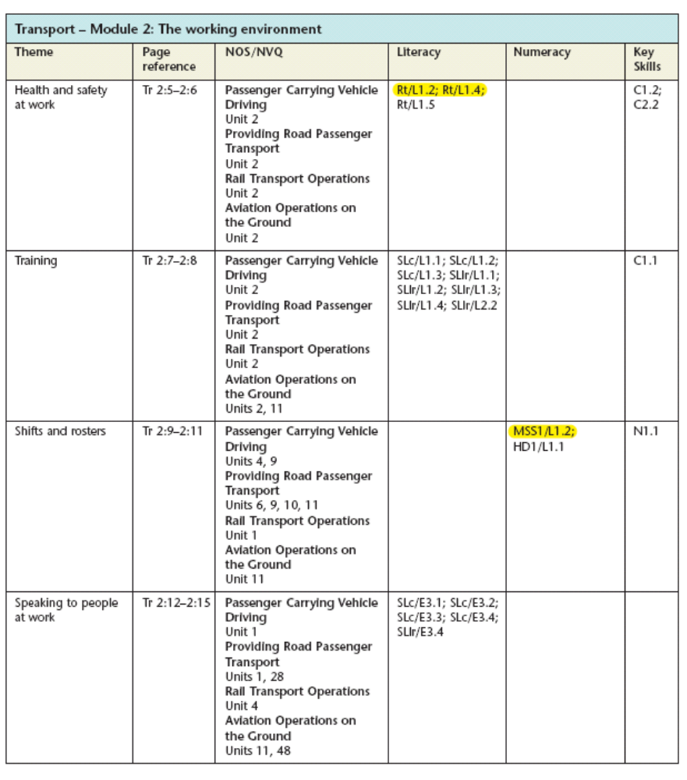
Skills checklist 2:0

Every workplace has its own ways of working. You need to make sure that you understand what is expected of you and what your role is. Working effectively is about working safely, working with a wide range of people and understanding workplace systems.
You will need all of the following skills to be safe and confident in your workplace. Tick all the skills you have now, then look again at the checklist later when you have used the materials.
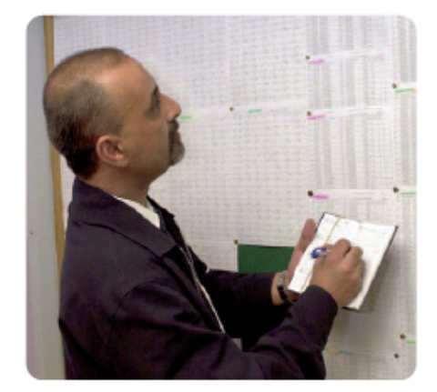
Skills for the working environment | Now | Later
Using the staff handbook
Understanding health and safety information
Following instructions and procedures
Working out your shifts and rosters
Speaking to people at work
Getting the most out of training

PAGES 2:1–2:2
Fire

Occupational setting
Every work environment displays many different types of signs. As these are not all health and safety signs it is important that workers can spot the safety signs amongst all the others. It is essential that individuals can help to protect others from danger. In order to do this, they must be able to locate, read and understand health and safety signs in their work environment. Many of the items in workplaces are highly flammable and fires can be particularly devastating to both property and people. In the event of fire in particular, delayed action could result in death. Everyone should know precisely where all the appliances are kept and how to use them correctly, without hesitation. It is necessary therefore to learn how to interpret the symbols, colours and written instructions on fire extinguishers and safety notices.

Materials
Fire safety notices from the workplace
Colour copies of focus page 2:1
Fire extinguisher information from the Source material (0:12), in colour
Fire action notice from the Source material (0:13)
Descriptions of different fires to match to appropriate fire extinguishers
Examples from the workplace of lots of different types of signs including advisory (e.g. one way), hazardous substances warning (e.g. COSHH), mandatory (e.g. wear ear protection), prohibition (e.g. no smoking), warning (e.g. give way), safety information (e.g. fire exit)
Real extinguishers or good-quality photos if these are not available

Learning outcomes
- To recognise how health and safety signs use specific colours and symbols (focus page, Tasks 1 and 2)
- To use the format in safety signs to aid understanding (focus page, Tasks 1 and 2)
- To recognise ways in which key instructions are made to stand out (focus page, Tasks 1 and 2)
- To work out or look up the meaning of technical words in order to follow instructions properly (focus page, Task 3)

Suggested teaching activities

Introduction
- Display the different types of health and safety sign and discuss with learners any they recognise, including where they can be seen in the workplace and the types of information they contain. If learners are unsure about the colours and symbols used in health and safety signage, develop a matching game, in which learners match colours, shapes and symbols to create signs and then ask other learners what message the sign gives, e.g. ‘What would an orange square with a black skull and crossed bones in it mean?’
- Steer the discussion towards fire signs and fire extinguishers. Discuss with the group the implications of not acting quickly and effectively in the event of a fire.
- Talk about fire types, the need to use different extinguishers for different fires, and the dangers of not using the right extinguisher (e.g. using a water extinguisher on an electrical fire).
- Ask each learner to describe briefly the particular circumstances of his/her work environment with regards to fire exits, fire procedures, etc. If learners are hesitant in replying, then say that this is a strong case for them to look very carefully at their individual circumstances. Stress the need to know how to use fire extinguishers and which equipment to use for each fire type.
  - As a visual memory exercise, organize learners into pairs and give each pair a different fire safety notice, if possible. Give the pairs one minute to note all the features in their notice – colours, symbols, words in bold, order of instructions, etc. As each pair feeds back to the group what they remember, note down their responses on the board/flipchart. Draw out the common features that were recalled with ease – was it the symbols, the colours, or the words in bold that helped them to remember? Were there any words they did not know? How could they find out their meanings?

Focus page
- Talk about the importance of colour in fire safety signs, particularly when it comes to fire extinguishers. Tell learners that all new extinguishers are red but with different coloured stripes which identify the type of extinguisher. If possible, show them real extinguishers or extinguisher wall labels.
- Point out that co lour is also used in fire action notices to help you identify what to do (blue) and what not to do (red). Refer to the particular format, e.g. blue information at the top and red at the bottom. Note that this is not the same for every safety sign.
  - Discuss where and how bold writing is used (plus any capital letters). What sort of information does it give? Why is bold text used? Make sure learners are aware that the purpose is to make it stand out from the rest of the text so that you notice it.
- Ask learners if there is anything about the signs used on this focus page that would make them hesitate if they were relying on them for information in the event of a real fire. Discuss the difficulties, focusing in on the specific technical words if necessary.
- Write a sentence on the board that includes the word ‘flammable’. Ask learners what they think this word means, using related words and the context of the sentence.
- Ask everyone to find the meaning given in the glossary and compare this with their meaning. Is it similar?
- Point out how the glossary can be used to find subject-specific words and their meanings. Make sure learners understand how to use it.

Curric. refs | NOS/NVQ | Key Skills
Rt/E3.3  Rt/E3.9  Rw/L1.2  Rt/L1.2  Rt/L1.3  Rt/L1.4 | PCV  Unit 2  RPT  RPT 2  RTO  Unit 2  AOG  Unit 2 | C1.2

Task 1
Use the information on fire extinguishers to answer some questions
Rt/E3.3
Rt/E3.9
Rt/L1.3
- Point out the glossary, to check the meanings of words used in the questions and on the signs.
- Emphasise that fire extinguishers can all look the same and that it is the symbols, careful use of colour and the key words that enable the user to distinguish one from another. It is vital to use the correct extinguisher – the wrong one could make the situation worse.
- Remind learners to look for the symbol that means DO NOT – this will keep them safe. Stress that acting to help others is not a good idea if you put your own life in danger.

If the learner has difficulty
- Check learners’ understanding of words on the signs and in the questions. Look them up in the glossary. The use of the word ‘live’ may cause some difficulties for some learners. You may need to talk about what is meant by ‘flammable liquid and metal fires’. Encourage the use of a personal dictionary to note down words and meanings that need to be remembered.
- Reduce the workload. Using the extinguisher labels from the Fire extinguisher information sheet in the Source material, ask learners to highlight all the symbols, the colours used and any words that are tricky to read and/or understand. Discuss findings with learners and then return them to the questions in Task 1.
- Ask some very straightforward questions about the carbon dioxide extinguisher label, e.g. What colour has been used to show it’s a carbon dioxide extinguisher? Find the symbol that has something to do with electricity. Is this symbol in the can use section or in the do not use section? Name some electrical equipment likely to be found in your place of work. Can you spot the symbol for electrical equipment on the other extinguishers?
- To increase comprehension, support learners to decode the text.
- Ask learners to devise their own ‘aides-memoires’ to help them remember the information they need to. This may include drawing, word/colour association, visual association, etc.

Extension
- Give the learner two or three appropriate scenarios from the workplace, e.g. a fire caused by a cigarette, an electrical fault, a fuel leak – which extinguisher would be used for each fire?
- Ask learners to list the most likely causes of fire in their workplace. Which extinguisher should be used for each fire?
- Learners’ responses to either of these activities could be used to make a checklist for colleagues.

Task 2
Read and understand a fire safety notice
Rt/L1.2
Rw/L1.2
- Talk about the difference between discovering a fire and hearing an alarm – the action you take will vary considerably.
- Draw attention to the headings on the notice.

If the learner has difficulty
- The third statement in ‘On discovering a fire’ is conditional (‘provided it is safe’) and may be difficult for some learners to understand. You may have to explain this meaning.
- You may need to discuss some of the language aspects of the notice for ESOL and other learners: ‘sound the alarm’, ‘appliances’, ‘hearing the alarm’, ‘tackle the fire’, ‘assembly point’, ‘authorised’.
- To increase comprehension, support learners to decode the text.

Extension
Learners can find out and write down the procedure for getting customers and workers out of their workplace in the event of a fire. Learners bring this information back to the next session, written as numbered instructions to the group.

Task 3
Circle the correct meaning of the highlighted words
Rw/L1.2
- Ask learners to read the whole sentence first before deciding on the appropriate meaning for each word, to encourage prediction skills.
- Discuss the use of technical or complex vocabulary in health and safety information. How do learners work out the meanings? What might be the impact of not understanding those words properly?
- Use the task to highlight the spoken equivalents of these words in the text: extinguish/put out, inhale/breathe in, etc. Encourage learners to keep a vocabulary notebook for lists of words typical of the more formal written style of language and their informal equivalents in speech.

If the learner has difficulty
- Discuss the likely meaning of the highlighted words, e.g. by talking about what will probably happen to a dry towel caught near flames – this should help learners to understand the word ‘flammable’. Ask learners to think of other materials that are flammable – these associations will help reinforce the meaning of the word for learners.
- Learners may prefer to look up words in the glossary first, rather than relying on the comprehension skills required for prediction. They may need guidance on using the glossary.
- To increase comprehension, support learners to decode the text.

Extension
Learners can find meanings for technical vocabulary in fire notices from the workplace.

Theme assessment
Ask learners to devise a short ‘quiz’ for the rest of the group based on fire information around the workplace. This can be a ‘treasure hunt’ style quiz, but with straightforward questions such as, ‘What does the red symbol on the Fire action notice mean?’
Fire (Focus) 2:1

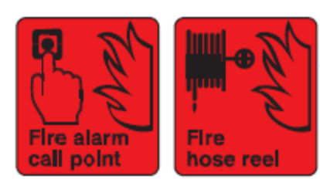
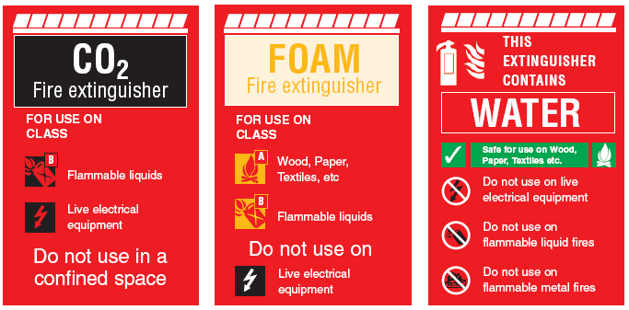
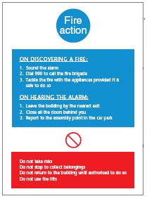
Health and safety signs use colour, symbols and words to help you find information quickly.
These are information signs. The colour red makes them stand out. The symbol of flames shows that they are to do with fire safety. Symbols and words show what sort of fire equipment is available.
This fire action sign uses:
symbols
colour
numbering.
It gives two types of instructions. Blue shows instructions about what you should do if a fire starts. Red shows instructions about things you must not do if a fire starts.
The symbols and words give information about the type of fire that can be put out with the extinguisher.
This symbol shows the things you should not do.
To follow information or instructions on safety signs, you need to understand the format (how it is set out) and the words that are used.
These signs give you instructions about how to use fire extinguishers.
Colour is used to show the type of extinguisher.
Fire (Task) 2:2

Task 1
Use the Fire extinguisher information from the Source material. Tick your answer to each question.
- On wood and paper fires, you should only use water. True __ False__
- Can you use a water extinguisher on flammable liquid fires? Yes __ No__
- The symbol in these signs represents: Lightning __ Electricity__ Danger__
- Carbon dioxide is for fires involving:
Live electrical equipment __ Wood __ Confined spaces __
- Black is used for extinguishers that contain:
Carbon dioxide __ Foam __ Water __

Task 2
Read the Fire action notice from the Source material. Decide whether these statements are true or false.
- You should call the fire brigade before sounding the alarm. True / False
- The assembly point is in the car park. True / False
- You can use the lifts if they are not near the fire. True / False
- You should always try to tackle the fire with an extinguisher. True / False
- You should not go back into the building unless you are
given permission by someone in charge. True / False
- You should get out of the building straight away, leaving
any personal belongings behind. True / False

Task 3
Circle the correct meanings of the highlighted words.

- Never try to extinguish a fire with flammable material, such as a dry towel.
- Do not use a gas-based fire extinguisher in a confined space such as a kitchen.
- Inhaling fumes from fire extinguishers can cause lung damage.

extinguish leave put out burn start
flammable easily set on fire damp fire-proof flaming
confined large open small busy
inhaling breathing out breathing in coughing burning

PAGES 2:3–2:4
The company manual

Occupational setting
New employees will be given a lot of information to read during the induction stage of their employment. They will not always need to read this information immediately, but they may need to access it in the future. Locating as well as reading and understanding this complicated information can be a problem. This focus page aims to highlight some reading techniques that learners can use when they need to access information and to extract detail from what they have read. Using the actual workplace policies and procedures manual from the learners’ workplace will make the activities particularly useful. Further practice of these reading skills can be found in the theme ‘Health and safety at work’ in this module.

Materials
Disciplinary procedure from the Source material (0:14)
Disciplinary procedures from the workplace
Workplace policies and procedures manual/staff handbook
Highlighter pens

Learning outcome
- To use a range of reading techniques including scanning and detailed reading to find information and read difficult text (focus page, Tasks 1–3)

Suggested teaching activities
Introduction
- Ask learners, What is the purpose of induction? Have they been given induction materials at work or at college? Establish what sort of information is included in these documents and the importance of understanding it. Are there any problems associated with understanding it?
- Investigate any existing strategies learners have for dealing with such texts and acknowledge the value of them if success is achieved.
- Stress the need for understanding to ensure that learners are aware of their responsibilities, and that their own rights are protected.
- Establish with learners that they may tackle different reading activities in different ways, depending on the task, e.g. scanning to find a telephone number, skimming to get the gist of a film review, detailed reading to be sure of the details of a job contract.

Focus page
- Make sure learners know what is meant by the term ‘company manual’ and can relate it to the document used in their own workplace (Staff handbook, Policies and procedures manual, etc.).
- Use the focus page to track through the different reading techniques that would be involved in finding specific information and reading it. These include:
- using a contents list (scanning for a key word): learners will need to decide what they are looking for before letting their eyes wander down the contents list until they see the word(s) they need. Liken this type of reading to looking in a telephone directory for a particular person’s name and number.
- scanning for a key word or phrase: give learners practice in counting or highlighting the number of times a certain key word appears in a short text.
- skimming the page to get the gist of what it’s about: liken this to looking quickly over a newspaper to find an article of interest. Things like headings or particular key words in the article grab the attention and give you the gist. You can do this with any text to see if it’s of interest before you read it.
- reading in detail: this may include reading a text in smaller chunks, reading it more than once, finding the meaning of unfamiliar words, repeating what has been read aloud or explaining it to somebody else.
- Practise each skill on the focus page and reinforce with further practice, using the Source material or workplace materials. Induction materials enlarged onto OHTs can act as useful examples to practise on.
- Use an organisation chart or other format to demonstrate how the same skills can be used in other contexts.
- As a group, identify unknown words and check that learners have strategies for understanding these. Learners will often be reluctant to say that there are words they do not understand – use questioning to check that words are understood. Don’t assume that learners can or will look up words. Introduce other strategies for finding the meaning of unknown words. ESOL learners will need additional support when checking words such as ‘disciplinary’ and ‘misconduct’.
- Reinforce the idea that the world is full of written material and it is impossible to read everything, so choices have to be made. We sift information by looking for the gist, by using contents pages and by scanning for particular information. Only then do we read carefully for understanding. Get learners to ask, ‘What do I need to know?’ ‘How am I going to find out?’

Curric. refs | NOS/NVQ | Key Skills
Rt/L1.4  Rt/L1.5  Rt/L2.7  Rt/L2.8  Rw/L1.1  Rw/L2.3 | PCV  Unit 2  RPT  RPT 2  RTO  Unit 2  AOG  Unit 2 | C1.2

Task 1
Scan text to locate information
Rt/L2.7
- Make sure learners have a copy of the Disciplinary procedure from the Source material.
- Remind them that they do not need to read the whole document in order to extract the information they need.
- Point out that the highlighted words on the task page will help them to locate information quickly.

If the learner has difficulty
- Scanning text is an advanced reading strategy. It requires practice and confidence. First identify with learners the purpose and general nature of the text they are looking at by asking direct questions. Allow learners time to look at headings and layout features.
- Check that learners can read the questions and are clear what they are looking for.
- Support them to scan for the highlighted words, locate the relevant text and then to read it in more detail. (Learners may wish to use a straight edge to help them work down a line at a time.) Use this supported model for each question and withdraw support as learners gain confidence.
- Offer learners further examples from the workplace as extra practice.

Extension
Learners will benefit from plenty of practice at scanning text for information. Give learners additional texts to practise with or ask them to use their own induction materials. In pairs or small groups, learners can give each other challenges to locate information.

Task 2
Find the meaning of words using a dictionary or glossary
Rw/L1.1
- Check that learners are able to use the glossary from this file or have other strategies that they can use to interpret unfamiliar words. ESOL learners could use a bilingual dictionary.
- Tell learners that definitions or explanations of words should be in language that they can understand.

If the learner has difficulty
  - Support learners to look up words using alphabetical order and to interpret meanings in their own words. Encourage them to use other strategies such as prediction and asking colleagues.
- Offer alphabet strips to help with the sequencing of the alphabet.
- Encourage all learners to keep a personal word bank in their folder or notebook.
Extension
In pairs, get learners to test each other: one learner chooses a word that is job-specific or technical and asks their partner to explain the word in simple terms. This can be conducted as a ‘Call my bluff’ game: ‘Do you think this word means (a) …, (b) … or (c) …?’

Task 3
Put text into own words to clarify understanding
Rt/L2.8
Rw/L2.3
- Discuss with learners how written information and guidelines used in many areas at work such as Health and safety and Induction can appear complex and difficult to understand.
- Reflect on the problems of understanding the language used in policies and procedures and discuss strategies learners can use, e.g. breaking text into chunks, looking up words, reading text aloud, getting the main idea, asking others, etc.
- Ask learners to work collaboratively on the text given in order to understand both the gist of the text and identify the key points in the text.

If the learner has difficulty
- Support learners to read through the whole text and talk about the gist of it. Highlight words that will help identify key points and discuss their meaning.
- Take each point separately. Read it aloud together. Verbalising can further aid comprehension.
- Words such as ‘emphasise’ and ‘conduct’ can be understood by using the context or by looking them up.
- To help learners with dyslexia or other language difficulties, key points from the passage can be cut out and/or produced on cards so that they can be examined in isolation. Learners who require additional support can also be referred to Skills for Life materials for extra work on reading.
- Offer learners further examples from the workplace as extra practice.
- Some learners experiencing difficulties with reading may prefer to be referred to a specialist literacy teacher.

Extension
Give learners other workplace texts to summarise.

Theme assessment
Ask learners to locate a disciplinary procedure from their own workplace and describe the approach the company takes to employee discipline.
The company manual (Focus) 2:3

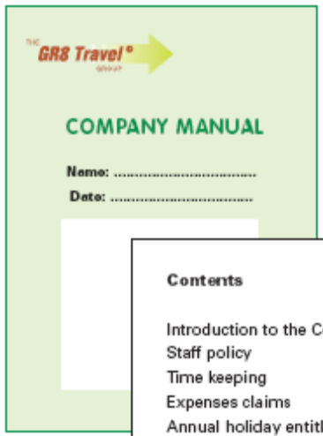
You cannot remember everything you are told. Sometimes you will need to look things up. The company manual contains all the information about policies and procedures of the company you work for.
Policies tell you about the rules for the company.
Procedures tell you how the rules are carried out.
If you do something wrong at work, look in the company manual for the Disciplinary procedure.
The contents page lists everything that is in the manual. You do not need to read every word of the list. Let your eyes wander down the list looking for the word ‘Disciplinary’.
First, glance over the whole page. Certain repeated words or particular phrases will stand out, giving you the idea of what the page is about.
When you know you have the right page, read it through to get the gist of it.
Then read it again more carefully. Reading it more than once is a good idea.
Tackle it a bit at a time to make sure you have understood.
Find out the meaning of any words you cannot explain.
Page 15 has all the information about the Disciplinary procedure.
Check that you have understood what you have read – put it in your own words or explain it to somebody else. If you still don’t understand … ASK!
You may be able to guess the meaning of some words from the other words around them. A dictionary or glossary may help here.
Contents

Page
Introduction to the Company 1
Staff policy 2
Time keeping 4
Expenses claims 7
Annual holiday entitlement
and management 8
Bank holidays and other leave 10
Sickness 12
Disciplinary procedure 15
Work patterns and break entitlements 16
Health and safety 18

15

Disciplinary procedure
This disciplinary procedure is to ensure that
company rules are complied with and standards
are safeguarded. The disciplinary procedure is
not viewed as a means of punishment. It is
intended to emphasise and encourage
improvements in the conduct of an employee.

The company manual (Task) 2:4

Use the Disciplinary procedure from the Source material to complete these tasks.

Task 1
Decide whether each statement is true or false. Find out by glancing over the page to spot the words in bold.
- The disciplinary procedure is viewed as a means of punishment. True / False
- Except in the case of gross misconduct, an employee will not
be dismissed for a first offence. True / False
- An employee will be invited to a disciplinary interview with the appropriate senior manager, line manager or supervisor True / False
- S/he is not entitled to bring with her/him a trade union representative, colleague or staff representative. True / False
- Offences of gross misconduct can lead to immediate
disciplinary action and then possibly dismissal. True / False

Task 2
- Use the glossary to find the meanings of these words.
- ensure___________________________________
- conduct__________________________________
- gross misconduct __________________________
- alleged___________________________________
- notified __________________________________

- Try the meanings out in place of the original words in the Disciplinary procedure.

Task 3
Explain to a colleague what this part of the Disciplinary procedure means.

This disciplinary procedure is to ensure that company rules are complied with and standards are safeguarded. The disciplinary procedure is not viewed as a means of punishment. It is intended to emphasise and encourage improvements in the conduct of an employee.

PAGES 2:5–2:6
Health and safety at work

Occupational setting
Every workplace should have a set of policies that everybody in the workplace should abide by. These set out the rights and responsibilities of everybody in the workplace and ensure that all workers and their employers are working together to a common set of standards. Policies are generally led by legislation, e.g. Health and Safety Law, Safe Lifting, Respect for Diversity/Equal Opportunities, etc.
The Health and Safety Law poster will be found in every workplace. This theme develops some of the reading skills, such as using format, skimming and scanning, required to read and understand this important document. These skills can be transferred to reading many other workplace policies. Further practice of these reading skills can be found in the theme ‘The company manual’ in this module.

Materials
Health and Safety Law poster from the Source material (0:15)
As many other workplace policies as possible – some made into OHTs

Learning outcomes
- To identify the purpose and gist of a policy by skim-reading main features like headings and titles (focus page, Task 2)
- To find relevant parts of a policy by scan-reading for particular words (focus page, Tasks 1 and 3)

Suggested teaching activities
Introduction
- Discuss the words ’rights’ and ‘responsibilities’ and their meaning in the workplace context. Relate them to what the learners understand of their rights and responsibilities regarding Health and Safety at work. Make two lists headed ‘Rights’ and ‘Responsibilities’ on a flip chart and add to them during the discussion.
- Widen the discussion to include how workers can find out about their rights and responsibilities at work. Steer discussion towards workplace policies and where they can be found.
- Point out that finding a particular policy often means searching through a lot of sheets of similar-looking written text. Using the OHP, flash up at least four different policies and ask learners to tell you which one showed a policy on, for example, eating and drinking at work.
- Ask learners what helped them to decide which was the right policy. The answer should be the title/headings and a few key words that drew their eyes around and down the page. The technique learners have resorted to is called skimming and is used to decide what the text is about and whether to read it.
- Using one policy from your prepared OHTs, ask learners to say how many times they can spot one given word. If you have an OHT that you can write on, highlight these words to see if you agree with the number they have found.
- Point out that once you have decided on a particular policy to read, you can use scanning skills to spot all the references to the subject you are researching. This is a research skill, often used in searching the Internet.

Focus page
- Refer learners to the focus page and summarise the points about the reading strategies used to find relevant information. Reinforce the idea that the world is full of written information and it is impossible to read everything so choices have to be made. We ‘sift’ information by skimming the text for relevance and gist (Is it about the topic I’m interested in? Is it worth going on to read this?) and then scan it for particular information.
- Learners need to know which words need to be scanned for. This includes deciding on key words and related words. Plenty of practice and examples are required for all learners to do this.
- Note that many learners, including those who are dyslexic, may need a lot of practice in these skills. Looking for information on a website is a good analogy for these reading skills:
- First you have a quick look at, or skim-read, the front page to see if it’s interesting or relevant to you.
- Then you look quickly – scan – through the sections on this front page and decide where to look next.
- You repeat this process, page by page, until you find the information you want to read.
- Then you read this carefully.

Curric. refs | NOS/NVQ | Key Skills
Rt/L1.2  Rt/L1.4  Rt/L1.5 | PCV  Unit 2  RPT  RPT 2  RTO  Unit 2  AOG  Unit 2 | C1.2  C2.2

Task 1
Scan the Health and Safety Law poster in the Source material and use the format to answer questions
Rt/L1.4
Rt/L1.5
- Remind learners that to find relevant information in a policy as large and initially daunting as the Health and Safety Law poster they should use as many visual clues as they can – in other words the format, which includes coloured sections, bold headings, boxes, etc.
- Make sure learners know they can make more than one choice if the information goes over into a new column (as with question 2).

If the learner has difficulty
- Dyslexic learners may have problems with the left-/right-hand aspect of the questions and may need support in this, e.g. by providing them with a page marked ‘L’ and ‘R’ at the top left and top right.
- Some learners may need extra practice with scanning techniques to improve their confidence.
- Talk through the poster as a whole, pointing out different sections and features and discussing it with learners.
- Ask learners to read the headings and subheadings.
- Work on the question together, pointing out the key words, e.g. ‘employee’.
- Ask learners another question relating to that section.

Extension
Ask learners to write down what they consider to be one very important duty of the employer and to say why they chose it.

Task 2
Skim a particular section of the Health and Safety Law poster to establish its purpose
Rt/L1.2
Rt/L1.5
Remind learners that skimming through the whole section quickly will give them the gist of its contents. Knowing the gist helps a reader to establish the purpose.

If the learner has difficulty
Give the learner three sentences each declaring a different purpose for the final section. The learner can then consider each and decide upon the correct one, e.g. (1) The purpose of the final section is to tell the employee about their legal duties; (2) The purpose of the final section is to list the publications that give more information about Health and Safety law; (3) The purpose of the final section is to inform staff that legal representatives can be appointed.

Extension
Learners can search the Internet for one of the publications listed to find out current availability and cost.

Task 3
Scan the Health and Safety Law poster and use the format to find information
Rt/L1.4
Rt/L1.5
- Ask learners if they know where the Health and Safety Law poster is located in their own workplace.
  - Remind learners that scanning is a quick way to locate information you need. Identify again
the use of headings, format and key words when scanning text.
- Explain to learners that scanning will help them to find the information they need to answer the questions without having to read all the text.

If the learner has difficulty
  - Scanning text is an advanced reading strategy. It requires practice and confidence. First give learners time to become familiar with the text. Allow learners time to look at headings and layout features.
- Check that learners can read the questions and are clear about what they are looking for. Identify key words from the questions that may help.
- Support learners to scan for the highlighted words, locate the relevant text and then to read it in more detail.

Extension
Give learners additional texts to practise with, or ask them to use their own induction materials or workplace policies manual. In pairs or small groups, learners can give each other challenges to locate information.

Theme assessment
Learners can use skimming and scanning skills to research information for an assignment on health and safety in the learner’s workplace, e.g. the procedure for evacuating the building.
Health and safety at work (Focus) 2:5

Every working person is protected by the Health and Safety at Work Act. This lists all the rights and responsibilities of both the employer and the employee.
How can you decide what it is about?
How do you pick out the parts you want to read?
When you read to get the gist, or general idea of what something is about, your eyes skim across the page.
Your eyes often pick out the things that stand out or look different.
This is a bit like looking over a crowd to get an idea of age group, sex and number.
Your eyes might pick out and read:
Titles and Subtitles – dashes
bullet points
italics colour bold words CAPITAL LETTERS underlined words
Sometimes you know what sort of information you are looking for.
You can search the text quickly for relevant words or phrases.
Your eyes move quickly, or scan, down the text to pick out the parts you want. This is like looking for your name on a list.
The words you scan for will depend on what you want to know.
For example, if you want information on your employer’s duties, you would scan the text for related words such as ‘employer’.
This helps you get a general idea of the subject of the writing.
This helps you to find the part of the text you need to read.
Health and safety at work (Task) 2:6

Tip
Look for key words taken from the question.

Task 1
Look at the Health and Safety Law poster from the Source material. Tick your answer to each of the following questions.
- Whereabouts on the poster is the information about your legal duties as an employee?
On the left-hand side__ In the middle__ On the right-hand side__

- Whereabouts on the poster is the information about the legal duties of an employer?
On the left-hand side__ In the middle__ On the right-hand side__

- Where is the space for the name(s) of people appointed to manage health and safety?
On the left-hand side__ In the middle__ On the right-hand side__

Tip
Read the section quickly to get the gist of what it is about.

Task 2
Use the Health and Safety Law poster from the Source material to answer this question: What is the purpose of the final section in the bottom right-hand corner of the poster?

Task 3
Find the Health and Safety Law poster in your own workplace.
- What are the names of the person(s) appointed to manage health and safety in your workplace?
- What are the responsibilities of the appointed person(s)?
- What are the names and locations of trade union or other safety representatives and the groups they represent?
PAGES 2:7–2:8
Training
Occupational setting

In Transport settings, many training sessions will be delivered verbally. Sometimes this means assimilating a lot of information and relying on memory. It is important that learners practise ways of picking out and remembering the actions they need to follow by listening carefully, particularly to imperatives, both positive and negative, such as ‘let’ or ‘don’t take’. Learners may also have to give instructions to others, such as members of the public or other colleagues. It is useful for learners to identify the features of good instructions and to practise these critical communication skills.
It may be necessary to adapt the generic manual handling techniques to the specific needs of the individual sector.

Materials
Training video – relevant to learners

Learning outcomes
- To learn about and use relevant active listening strategies (focus page, Tasks 1–3)
- To use key instruction words to help distinguish between what should be done and what should not be done (focus page, Task 1)
- To recognise key order words in instructions (focus page, Task 2)
- To clarify and confirm understanding (focus page, Task 3)

Suggested teaching activities
Introduction (Audio 6)
- Introduce the theme by playing the audio clip of the training featured on the focus page or something else relevant or interesting to the learners.
- Ask each learner what he/she picked up from the training. Elicit the fact that they weren’t ready for it, had no opportunity to ask questions, take notes, confirm what they heard, etc.
- Ask learners about their experience of listening to training. What are the problems? What are good instructions? What can go wrong if they don’t understand or follow work instructions?
- Ask learners to share existing strategies for remembering training. Note ideas on a flip chart.

Focus page (Audio 6)
- Work through the tactics for the listener given in the boxes on the focus page. Some learners will need to go through the vocabulary used first in order to understand the points raised.
- Listen again to the audio clip. Apply the points on the page to the audio script (given in the speech bubble) by asking: How many instructions are there? What are the key details here? What should you not do? Are there any order words? How would you put the first two instructions into your own words?
- Discuss other order words and phrases, e.g. ‘before you do anything else’, ‘at the end’, etc. Write these on the board.
- Discuss instructions that are conditional, i.e. that depend on something else happening, and talk about the words that signal that, e.g. ‘when’, ‘if’, ‘once’, ‘unless’, etc.
- Look at the examples of self-questioning based on the instructions on the page. How will this help the worker to establish exactly what to do?
- Talk about what is meant by being an ‘active listener’ and why this is important. You may need to introduce the term ‘body language’ and demonstrate what this means. This is a useful focus for some role-play on active listening: one person talks or asks questions, the other gives no feedback, either verbally or in body language.
- Listen to the audio clip of the instructions in the speech bubble. Ask learners to make a brief note of all the instructions in their own words, in a way that helps them to remember them, e.g. by using numbers or bullets. Stress that as long as they can read their notes back, style and spelling are not important.
  - Ask learners to use their notes to explain to a partner what to do. (This helps to confirm whether the instructions have been noted down clearly enough.)
- Return to the strategies for remembering training noted on the flip chart. Can learners now add any more? Learners may like to visit www.mindtools.com for further suggestions. Dyslexic learners may need support to access this site.
Curric. refs | NOS/NVQ | Key Skills
SLlr/L1.1  SLlr/L1.2  SLlr/L1.3  SLlr/L1.4  SLlr/L2.2  SLc/L1.1  SLc/L1.2  SLc/L1.3 | PCV  Unit 2  RPT  RPT 2  RTO  Unit 2  AOG  Unit 2  Unit 11 | C1.1

Task 1 (Audio 7)
Listen to a set of instructions and pick out the things that must be done and things that must not be done
SLlr/L1.2
- Look at the tips on the page and explain that learners should listen out for positive and negative instructions.
- You may want to spend some time on the different ways that this type of instruction can be given (e.g. ‘make sure’, ‘do this’, ‘clear the…’, ‘you should/must…’, etc.). Confirm that work instructions can be framed in a number of different ways and it is important to recognise these as instructions, i.e. telling you what to do.
- Play the audio clip or read the script through once, for gist.
- Play or read it again, this time asking learners to listen for the words that tell them what they must do. Learners could discuss this in pairs. What are the things that must be done? Learners should make a note of these instructions.
- Replay the audio clip so learners can confirm their responses.

If the learner has difficulty
- There may be some vocabulary issues for ESOL learners, e.g. ‘step over obstacles’, ‘keep your body balanced’. The teacher could re-formulate the instructions and allow time for discussion about the meaning. Illustrations also help understanding. Some of these can be found in manual handling leaflets.
- Make sure learners know which words to listen out for. In groups, give learners responsibility for listening for one instruction each using a key word or phrase such as ‘always’ or ‘never’.
- Ask direct questions about what they heard.
- Read the audio script in smaller chunks, no more than one sentence at a time. Ask learners, Does the person tell you to do something? What?
- Check learners have understood the instructions by asking them to explain the instruction to you but in their own words. They can then practise the instruction in pairs.

Extension
- Discuss strategies learners can use if they are having difficulty following instructions.
- Give learners some verbal instructions from their own workplace about how to use a piece of equipment. Learners should practise making notes of the instructions, perhaps in columns of ‘dos’ and ‘don’ts’.

Task 2 (Audio 8)
Read some instructions given out of order and number them in the order they should be followed
SLlr/L2.2
- Explain to learners that they need to listen out for key order words to help them decide on the correct order. Point out the example words in the tip box.
- Explain that they can write the numbers 1 to 5 next to the instructions. They should write in pencil in case they change their minds.
- Explain that they will be able to listen several times to check the order.
- Play the audio clip or read the script once for gist. Learners will benefit from getting a good overview of what is happening. Allow them to discuss this if needed.
- Read the statements in the question.
  - Play the audio clip again, asking learners to listen for key order words/phrases (learners might jot these down).
- Discuss the words/phrases and the order they suggest.
- Play the audio clip again and let the learners number the instructions.
- Play the audio clip once more for learners to check their order.

If the learner has difficulty
- This requires good listening skills, so some learners might have difficulty retaining the information or following it all through.
- To help learners focus on order words and expressions, try reading out the script without the order words first and using pauses.
- Then read the audio script in smaller chunks from where the instructions actually start, no more than one sentence at a time. Ask learners, What was the order word or phrase you heard?
- In small groups, give each learner one specific instruction or key phrase to listen for so that they do not have to listen for everything.

Extension
Choose a scenario relevant to the learners’ workplace. Ask learners to give a set of instructions about that scenario verbally to a partner, putting the instructions in order and emphasising key words including order words and ‘do’ and ‘do not’ instructions. The partner makes notes from the instructions and can ask questions to confirm information or check understanding.

Task 3 (Audio 9)
Ask questions to check or confirm information
SLlr/L1.1
SLlr/L1.2
SLc/L1.3
- Alert learners to the fact that while listening to the next audio clip they should be thinking about any aspects they would like clarified or confirmed.
- Play the audio clip through once for gist.
- Remind learners of the different ways they might frame their questions, using the focus page as a reminder. They might include questions that ask for certain things to be repeated, or to confirm their memory of an instruction. Keep a record of these on OHT or on the board. Discuss questions they could ask about the safe lifting instructions.
- Play the audio clip again or read the script.
- Ask learners to write their questions on a separate piece of paper.
- ESOL learners should practise questions orally.

If the learner has difficulty
  - Emphasise that correct spelling and grammar is not the point here. It is more important that learners note down questions that are important to them.
- Conduct the task verbally if writing is a barrier.
- Replay the audio clip or re-read the script as necessary.
- Support learners by asking questions to check their understanding. If they cannot answer the questions, they could use them as their own questions.
- Assist learners to prepare a list of ways of asking these questions for future reference, e.g. ‘Can you explain …?’ ‘How exactly do I …?’ ‘Did you say you wanted me to …?’

Extension
In pairs or small groups and using the script from the audio or something relevant to the learners, ask learners to act as trainer and trainee. The trainee should ask his or her own questions about the given instructions and the trainer should answer them where possible. A third learner could offer non-judgemental criticism of the way the questions are asked and answered. Swop roles.

Theme assessment
As a group, learners can devise a checklist for listening to instructions and apply it to the workplace.
Training (Focus) 2:7

Listening to training carefully helps you to follow instructions properly and do your job more effectively. Safety instructions are for your protection, so it is essential that you understand what to do.
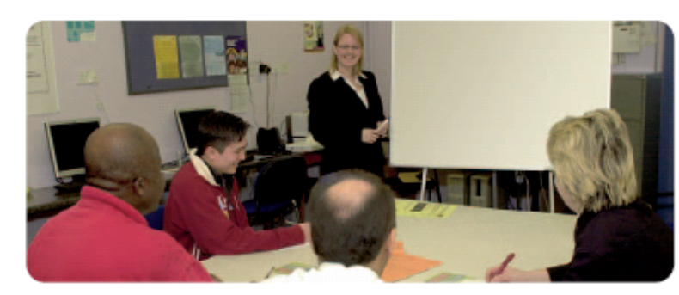
(Audio 6)
OK, are we all here? Good. There are some general points about lifting things that you should remember before you start. First of
all, ask yourself if it is absolutely necessary to lift the load. If so, ask yourself how heavy or bulky the load is and whether it should be lifted by a truck or a trolley. Next, think about where the load is going to end up and plan your route to get there so that you are aware of any possible hazards in your way. Also, before you start, check that the load is packed securely. I’ve seen the bottom of a box give way more than once!
Is there any particular order to do things in?
What questions can I ask to make it clearer?
So I’ve got to look out for things I might trip over.
Is there anything I must not do?
What must I do?
Is there anything I must do if something else happens?
Look at the speaker and concentrate on what he or she is saying.
Keep a notepad to jot down what you have to do.
Ask questions to help your understanding. Can I just check that …? Can you tell me what you meant by …? Please could you repeat the part about …?
Listen carefully for the key details.
Listen for:
- key words about what to do and what not to do
- words that tell you about the order to do things in.
Keep a mental count of the number of things to do.
Repeat instructions in your own words to check understanding.
Training (Task) 2:8


Think before you lift!

Task 1 (Audio 7)
Listen to the first part of the training.
Put a cross (X) by the things you should not do.
Put a tick (✓) by the things you should do.
Check your route.
Step over obstacles while carrying the load.
Keep the body balanced.
Bend straight over the load.
Bend at the knees and hips.
Use your leg muscles.
Twist your body.

Tip
X Listen out for words like ’never’, ‘don’t’ and ‘mustn’t’ when listening for things you should not do.
✓ Listen out for words like ‘always’ ‘make sure’, ‘must’ and ‘should’ when listening for things you should do.



Task 2 (Audio 8)
Listen to the next part of the training. Number the
instructions in the order they have to be followed.
Spread your feet.
Grasp the load firmly and close to your body.
Stand close to the load.
Bend your knees, keeping your back in a natural position.
Lift the load slowly, raising your head.

Get your body in the right position.

Tip
Listen out for the key order words or phrases like ‘first’ or ‘next’.


Task 3 (Audio 9)
Listen to the last part of this training session.
Think of some questions you would like to ask the trainer
Shifts and rosters

Occupational setting
In many Transport settings, timetables and planning are highly complex, involving many staff and a wide range of activities. Rosters are used frequently as a means of planning and scheduling tasks and for informing staff of their duties. It can also be important for staff to see which duties are covered by other people. The ability to extract and interpret information presented in tabular format is vital to the effective and efficient working of a team. There may be other issues related to reading these tables such as using a key, reading times in different formats and understanding abbreviations.

Materials
Selection of rosters, e.g. weekly duty rosters, lunchtime rosters, duty sheets, etc.
Paper copies of the Shift roster from the Source material (0:16), plus large version on OHT
Roster gap-fill exercise from the Source material (0:17)
Time matching cards from the Source material (0:18–0:19)
Calendar from the Source material (0:20)

Learning outcomes
- To understand what sort of information should be on a duty roster and why it is helpful (focus page)
- To practise finding information about duty dates and times from a roster (focus page, Tasks 1–3)
- To understand the various formats that can be used to record dates and times on rosters (focus page)
- To extract and interpret information from a particular roster format (focus page, Tasks 1–3)
- To record relevant information from the roster on a calendar (focus page, Tasks 1 and 3)

Suggested teaching activities
Introduction
- Ask learners to think about rosters that they use in their workplace.
- Discuss the importance of being able to extract information from a roster. As a group, think about some of the problems that could happen if a roster is not read or followed properly.
- Look at a range of rosters from the workplace. How can learners tell what the roster is about? (by reading the title and the column and row headings) Discuss the way the roster is set out in columns and rows.
- Which of the range of rosters examined do learners use? How do their rosters differ from the examples? How are they used? Do learners experience difficulty reading large wall-based rosters? What strategies do they use to help them keep track? (using a finger to track across rows and up and down columns)
- Explain that although rosters are not all alike, learners need to be able to locate certain key things on a roster to help them find out when they are working, or what they are doing each week.
- Show learners the Shift roster from the Source material on OHP. Using a piece of paper, cover up all but the main heading. Ask learners to predict from the heading what information they might expect to find on the roster. If necessary, use prompt questions, e.g. Do you think the names of the full-time staff will be on it? Note down their ideas.
- Give learners a paper copy of the Shift roster from the Source material to refer to. Uncover the full roster on OHP and ask questions that require learners to locate information on it to get an overall impression of what it contains. Ensure you cover the following general information:
- Names of staff: Where are the staff members’ names written? How do you know? How does the key help you? How would your name be written on this roster? Summarise the information discussed, e.g. So the staff names are written as initials here on this roster. The key tells you what their full names are.
  - Shift times: Where are the times of the shifts written? How do you know? Does the heading at the side help? Is the start time written on the top or bottom of the line? What does the time below this show? Why are there gaps in this section? Where are the days of the week written? How do these link to the times? Summarise the information discussed, e.g. So the time each shift starts and finishes on each day of the week is shown here. The short lines show when someone has got a day off.
- Shift dates: Where are the dates for the shifts written? ‘W/c’ stands for ‘week commencing’ – what does that mean? What day does the week commence (begin) on this roster? How do you know? Summarise the information discussed, e.g. So the date for the Monday of each week is shown here. Relate information to the shifts worked by the learners. On which day of the week do their shifts commence? How is it written on their roster? (possibly w/c Mon 31st Oct or w/c 31/10/06)
- Explain that learners are now going to look in more detail at the information they can get from this roster so they can use similar strategies for reading rosters in their own workplace.

Focus page
- Read through the introduction and information in the labels as a summary of the important aspects of rosters.
- Before using the roster to find information, learners need to understand how to read or work out the dates and times of the shifts. Ask direct questions to test their understanding, e.g. What time is 0600? What is this date?
- If learners need more practice in understanding times, use one or both of the accompanying exercises from the Source material. The Roster gap-fill exercise allows learners to practise writing times, while the Time matching cards has learners matching 12-hour and 24-hour times written out in figures and in numbers.
- If learners are having difficulty understanding how to work out the dates of each day of each week as shown on the roster, they could use the Calendar from the Source material (if they know how to use it) and/or a straight edge to help them work across the rows one at a time, or an L-shaped card to aid tracking. Remind learners that ‘w/c’ means ‘week commencing’ so they know which date to count on from.
- When learners are ready, look at the highlighted example on the page. Ask which week it concerns and which staff member it gives information about. Then ask learners to note his shifts for each day of that week either on a piece of paper or on the calendar – writing the times in a format that they understand.
- Go through this as a whole class and find out how (if at all) they noted days off.
- Read through the steps for using the roster at the bottom of the page as a way of summarising the sort of things learners did to find the information asked for. Discuss any other strategies they used.
- Ask learners to repeat the exercise for Chris Jones and go through their answers as before.
- Now ask learners to imagine they are Chris Jones and have been given a copy of this roster. They want to find out what shifts they are on every week. What would they do first? (e.g. find their name each time it appears on the roster) Encourage them to circle Chris Jones’ name each time it appears on the roster.
- Ask what they would do next. (e.g. read across the rows to find what shifts they are on) Ask them to highlight or draw a line from the name across the row to the shift times. Explain that this reminds them where their own shift times and days off are recorded. Ask learners questions that require them to extract information from the roster about these particular shifts, e.g. What time does Chris Jones start work on Thursday 3rd August? What time does he finish on Tuesday 8th August? Which days does he have off during the week of 14th August?
- Note any learners who are not answering questions and ensure further support is given before they do the activities. This may mean going back over everything, repeating particular stages, giving more practice with the format for dates or times, writing down the date of each day recorded on the roster a week at a time, or working through several more examples of extracting particular information.
Curric. refs | NOS/NVQ | Key Skills
HD1/L1.1  MSS1/L1.2 | PCV  Unit 4  Unit 9  RPT  RPT 6  RPT 9  RPT 10  RPT 11  RTO  Unit 1  AOG  Unit 11 | N1.1

Task 1
Use information from a roster to mark days off on a calendar
HD1/L1.1
- Make sure learners have a copy of the Shift roster and the Calendar from the Source material.
- Explain that calendars provide a useful way of recording shifts from a roster.
- Check that learners understand the format of the calendar. Ask them direct questions to test this, e.g. Which month is it mainly for? How do you know? Are the days of the week written in the same way as on the roster? What do the numbers stand for? etc. Make sure learners understand which dates apply to which day of the week (working downwards for each day).
- Discuss how ‘days off’ are recorded in the calendar. Have entries been written above or below the days they refer to?
- Ask learners to use the roster to find the two ‘days off’ that have already been noted down on Jagpal’s calendar. Discuss the strategies learners used to find them and the order they did things in. Point out the strategy described at the foot of the focus page as one way of finding information.
- Explain that the task is to record all the other days in August that Jagpal is not on duty.

If the learner has difficulty
- Compare and contrast the two versions of date format on the roster and the calendar. Learners may wish to write the abbreviated days of the week in full on the column headings of the roster. Give learners practice in finding given dates as quickly as they can on both the roster and the calendar.
- Learners may find it useful to ‘personalise’ the roster, e.g. highlight ‘JA’ in each weekly column on the roster or shade the days on the roster in a different colour, etc.
- Use sticky notes marked ‘Day off’ so that learners can physically move them around on the calendar. This reduces the burden of recording.
- Some learners may have difficulty tracking across the roster. Encourage them to use a ruler or L-shaped piece of card to look at each set of seven days at a time. They may wish to do the same with the calendar.
- Give additional examples for further practice.

Extension
Ask learners to use the calendar to record the times that Jagpal starts and finishes his duties each day in August.

Task 2
Find information from a roster
HD1/L1.1
- Remind learners of the strategies discussed earlier to extract and interpret information from the roster.
- Explain that questions can be completed in any order, but they all use the same roster.
- Make sure learners have a paper copy of the Shift roster from the Source material.

If the learner has difficulty
- Observe learners tackling the task and identify the type of difficulty learners are experiencing. This may be in reading and understanding the questions, navigating the roster, or it may be to do with reading/recording the times and dates.
- Appropriate solutions will vary from learner to learner, depending on the nature of their difficulty:
- Reading and understanding the questions: Read through each question with learners and talk it through. Discuss what needs to be done and check that learners know how they will go about it.
  - Reading the roster: Some learners may have difficulty tracking across complex tables. Go through each step with them, starting by circling the name of the person’s shifts they are taking over. Encourage them to use a ruler or L-shaped piece of card to track across the rows.
- Reading/recording the times: Learners can refer to the list of matching times they made earlier, if this activity was chosen. However, the concept may need further explanation and practice. Support with Skills for Life materials at Entry 2 may be needed.
  - Give additional examples for further practice.

Extension
Ask learners to make up more questions for each other about Raj’s shifts. Opening phrases can include, ‘What day …?’, ‘What time …?’ and ‘Which week …?’.

Task 3
Use information from a roster to fill in work shifts on a calendar, then use information from the calendar and roster to check appointment dates or times
HD1/L1.1
- Go through the scenario and the first part of the question to make sure learners understand that they are to record the shifts they are covering on the calendar. They can record the times and days off in whatever format they like. Explain that they will be able to use this information to help them answer question 2.
- Make sure learners have copies of the Calendar and Shift roster from the Source material.
- Make sure they understand how to answer question 2 – circle ‘Yes’ or ‘No’ and then write in the reason. Give an example.

If the learner has difficulty
- Learners may have the same reading problems as with Task 2 or find the format of the calendar a problem, especially in recording the correct shift times on the correct days. Learners might find it easier to cover up all but one row of the roster and all but the co-ordinating week on the calendar, to help them focus on the relevant parts a bit at a time.
- Support learners to locate the information from the Shift roster first, e.g. by highlighting Zara Mason’s initials, then using a straight edge to read across each row and work out the dates for each day in that row. They may want to write the dates down so they do not have to remember them or keep working them out.
- Check that learners know how to record the information on the calendar. If necessary, act as scribe to record the first week of dates on the calendar as an example and get learners to cross-check it against the dates from the roster.
- Read each part of question 2 one at a time and remind learners that they should imagine they are doing Zara Mason’s shifts. Encourage learners to use the completed calendar from question 1 to check whether or not they will be working on the dates or at the times mentioned. Ask them why they can or cannot make the appointment and write down their reasons for them, to limit the burden of writing.
- For part d of question 2, encourage learners to use their completed calendar to find a Saturday and Sunday in a row when they are not working. They could shade these in before writing down the dates.
- Give additional examples for further practice.

Extension
- Ask learners a range of more complicated questions about the same shifts, e.g.:
- questions that require them to work out time: Can you make an hour’s hair appointment at 11:30 on Friday 4th August?
- questions about the week commencing 4th September (this requires them to interpret information directly from the roster without the benefit of a calendar)
- questions that ask them whether they would or would not be able to get to particular appointments if they were working these shift times in their own place of work. (The answers will then vary from person to person depending on their own travel times to or from work.)

Theme assessment
Ask learners to use a roster from their own place of work to record their own duties or shifts. They can use a calendar, diary or any other preferred way of recording the information. Check that they have recorded the information accurately.
Shifts and rosters (Focus) 2:9

When there are lots of people working different shifts, a roster is used to keep track of everyone’s working times. A roster is a table that lists:
- all the members of a team
- the days and times they are on duty.
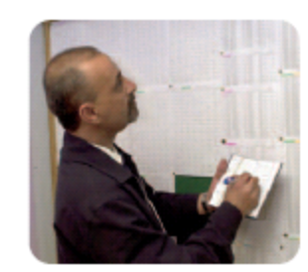
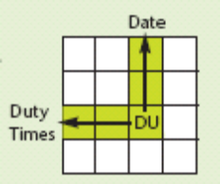
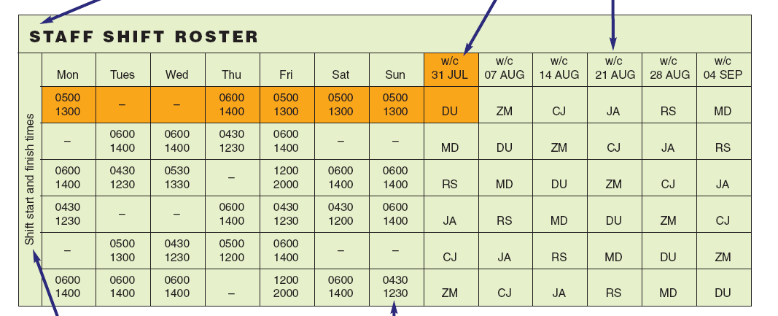
Some rosters have a key to explain the symbols or abbreviations used.
The main heading tells you what the roster is for.
Column headings tell you what information is recorded in each column.
Other headings give further information about what is recorded on the roster.
Days, dates and times can be written in different ways. Make sure you can read them.
KEY
CJ Chris Jones
DU Dev Uppal
JA Jagpal Ali
MD Matt Davis
RS Raj Singh
ZM Zara Mason
Try this
Which shift is Dev Uppal working on Tuesday 15th August?
How to use this roster
- Find the date at the beginning of the week that you want to know about.
- Track down the column to the initials that you are looking for.
- Track across the row to find the duty times for each day of that week.
Shifts and rosters (Task) 2:10

Task 1
Jagpal Ali uses a calendar to record all his days off.
Use the Shift roster from the Source material to complete his calendar for the month of August.
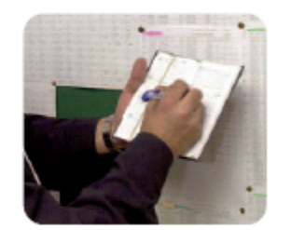

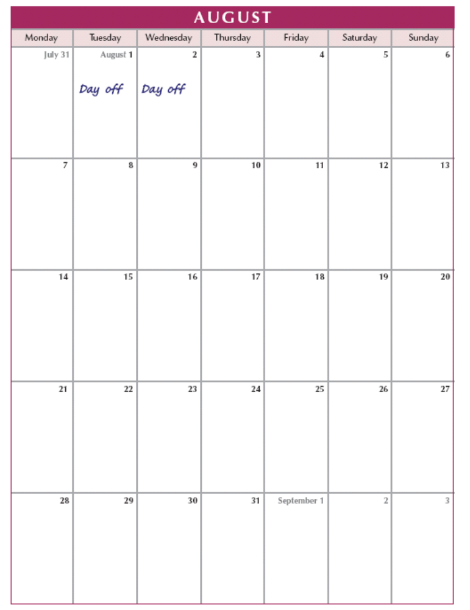

Shifts and rosters (Task) 2:11

You will need the Shift roster from the Source material for these tasks.


Task 2
You are taking over the duties of Raj Singh for the 2 weeks commencing 31st July and 7th August.

- At what time will you start work on Monday 31st July?

- Which day will you have off in the week commencing 31st July?

- At what time will you start work on Monday 7th August?

- Which two days will you have off in the week commencing 7th August?
_______________________________ and _________________________________

Task 3
You have been asked to cover for Zara Mason for 4 weeks starting on 31st July.

- Record your shifts for these weeks on the Calendar from the Source material.
- Use information from the Calendar and the Shift roster to answer the following questions. Give a brief reason for your answer.
- Will you be able to make a hair appointment for Thursday 3rd August at 2.00 pm?
Yes No because ___________________________________
- Will you be able to go shopping with a friend on the morning of Tuesday 15th August?
Yes No because ___________________________________
- Will you be able to meet a friend for lunch at 12 o’clock on Friday 25th August?
Yes No because ____________________________________
- Which weekend in August will you be able to stay with a friend in London?
Saturday ________________ and Sunday ___________________
Tip
To read a roster:
- find the initials the person first
- draw lines from the initials across the row
- check the column headings to fin the right w/c date and the days in that week.
PAGES 2:12–2:15
Speaking to people at work

Occupational setting
Workers in the transport industry will need to speak to a lot of different people including workmates, team leaders, managers and customers. There will be occasions when important information needs to be communicated to people in difficult or noisy situations. It is important to understand what can affect spoken communication in the workplace, for example the need to adapt language to suit the situation, the person, and the purpose. This theme introduces some of the skills required for adapting language, tone and body language to the situation.

Materials
Photographs of people talking to each other or communicating together, if available – these can be taken in the workplace using digital technology and projected using PowerPoint

Learning outcomes
- To understand what affects spoken communication in the workplace (focus pages)
- To recognise the purpose of communication (focus pages, Task 1)
- To adapt language to suit the situation (focus pages, Tasks 2 and 4)
- To recognise and use non-verbal communication/body language to communicate information (focus pages, Tasks 3 and 5)

Suggested teaching activities
Introduction
- Use photographs as a starting point (if available). Discuss different ways of communicating with people, both verbal and non-verbal, e.g. gestures, expressions, formal hand signals, etc. Ask learners to think of everyday examples, not just from work.
- Give learners a number of hand signals related to their own work setting, e.g. traffic control or some generic recognisable signals. Ask learners to say what they mean. How do they know? What could happen if they don’t recognise a signal such as ‘stop’?
- Discuss any problems with reading body language. Use these to highlight both the things that are understood by everyone in the group and the things that are interpreted differently.
- Learners might like to give examples of signals used in other countries or cultures that mean something different. Use this to point out that there has to be a system at work that suits everyone.
- Discuss why it is important for you to understand people and for them to understand you. For example:
- to keep everyone safe
- to carry out your part of the job effectively
- to work well as a team
- to avoid disagreements and misunderstandings
- to get the job done properly.

Focus page 2:12
- Go through each numbered section, reading through the points and discussing the questions in as much detail and possible.
- Discuss useful phrases or ways of checking the other person has understood what you said. For example:
- – ‘Did you follow/get that ...?’
- ‘Shall I run through that one more time?’
- ‘Have I missed anything out?’
- ‘Is there anything you want me to repeat/explain?’
- ‘You look a bit confused. Would it help if I said it again?’
- If appropriate, discuss any everyday signals used in the workplace.
  - Remind learners of the meaning of ‘non-verbal’ messages. Give a range of body language examples to illustrate this.
  - Summarise the consequences of misunderstanding hand signals or gestures including the possible effects on safety and professional relationships.
- Organise learners into pairs. Give one person a piece of paper with an emotion written on it and ask them to say ‘good morning’ in that tone. The other person has to respond in any way they like and then analyse the effect of what they heard on them as a listener – how it made them feel or react.
- Continue the activity using the sentence, ‘How are you?’ emphasised in different ways, e.g. ‘How are you?’ ‘How are you?’ ‘How are you?’
- Ask learners to experiment using different tones of voice in order to ‘hear’ the difference in other exchanges. This should include:
- saying the same sentence emphasizing different words
- saying the same sentence with a different emotion, e.g. ‘bored’, ‘angry’, etc.
- Introduce intonation and how this contributes to meaning. Give spoken examples of questions, statements, exclamations, requests, etc. and ask learners to listen for the difference. Then write these on the board with their proper punctuation so learners can also see there is a difference.
- Note: ESOL learners may need lots of practice of appropriate intonation patterns for questions, requests, suggestions and so on, for example with (a) a supervisor and (b) a colleague.
- Discuss the meaning of ‘open’, ‘closed’, ‘positive’ and ‘negative’ body language, giving examples and asking what the learners interpret from them.
- Make a list of positive and negative body language. If a digital camera is available, photograph and display examples of each.
- Talk about how learners feel if they are talking to someone who is looking away, folding their arms, yawning, etc.

Focus page 2:13
Relate the ideas discussed on focus page 2:12 to the ideas and practice on this focus page.
- Read through the information and discuss the questions for each section. Note any differences in interpretation of positive body language.
- Note: there is cross-cultural variation here, including the issue of personal space. Discuss this and pull out any differences.
- Point out and read through the ‘Tips for good communication’.
- Conclude by giving learners three or four different everyday work scenarios. Ask learners to discuss ideas and then compile a list of ways of speaking clearly to be heard and understood in these different circumstances. Role-play if appropriate.

Curric. refs | NOS/NVQ | Key Skills
SLc/E3.1  SLc/E3.2  SLc/E3.3  SLc/E3.4  SLlr/E3.4 | PCV  Unit 1  RPT  RPT 1  RPT 28  RTO  Unit 4  AOG  Unit 11  Unit 48 | n/a

Task 1 (Audio 10)
Recognise the purpose of speech
SLc/E3.2
SLc/E3.4
- Explain that learners are going to listen to a short speech and that they need to decide on the purpose of the speech.
- Remind learners of the choices of purpose they have on the page, and point out the tip.
- Play the audio clip or read the script: ‘I’ve just … er … noticed that Pete’s taken another break. He’s not well. What should I do about it?’
- Discuss any expressions that might be unfamiliar, such as ‘He’s not well’ (suggesting ‘He’s ill’). Encourage learners to work out the meaning from the context.
- Get learners to concentrate on the intonation. Repeat the speech for further clarification.
- Repeat the speech as many times as required.
If the learner has difficulty
- Learners may find the spoken idiom problematic as it does not sound like a direct question. Split the audio clip into three, stopping after the first sentence to ask direct questions such as What does that mean? Encourage learners to put it into their own words.
- Do the same with the second and third sentences. Encourage learners to listen out for the key word ‘What’. Ask them whether this word helps to give them a clue about the purpose.
- Go through each answer option, applying it to the whole speech. Read the speech aloud as many times as necessary.

Extension
- Ask learners to explain how they might reword the information/question when speaking to their supervisor.
- Learners should share and discuss their examples, comparing the language used.

Task 2 (Audio 11)
Recognise appropriate language
SLc/E3.2
SLc/E3.3
- Set the scene by reading out the introduction. Discuss what dangers there might be round doors so that learners are aware of the importance of this communication.
- Play the audio clips and discuss any difficulties learners may face due to the use of slang terms, e.g. ‘Watch it!’
- Play the audio clip again to reinforce the decisions and discuss it as a whole group, making points about the style and appropriateness of the language. Refer to the examples on focus page 2:13 as a reminder for learners.

If the learner has difficulty
- Go through any language issues, e.g. the meaning of non-standard forms such as ‘Watch it!’
- Encourage learners to say each possible choice aloud.
- Where learners are struggling to understand the language, emphasise the learning point that if they can’t understand it then the customer may not understand it either.
- Encourage learners to share ideas in groups. They can take the speeches out of order, dealing with the ones they find easiest to recognise as inappropriate first.
- Some learners might want to pick out their answer first and then discuss why they rejected the others.

Extension
- Ask learners to discuss what ‘message’ is being given to the customer by the language and tone used in each instance. They can start by discussing how the speaker comes across, e.g. as aggressive or rude, etc.
- Learners should feed back their observations to the rest of the class.

Task 3
Read meaning from facial expression
SLlr/E3.4
- Make sure learners understand the instruction for this task.
- Put learners into groups so that they can discuss and share their ideas.
- Make sure learners know that they are to choose and tick one of the answers in the boxes but should discuss all the answers.
- Read through the tip.
- Encourage learners to ‘act out’ the facial expressions that they think go with each description in the boxes if this helps them to discuss the photo.

If the learner has difficulty
- Encourage learners to reject answers before selecting the correct one.
- Guide them through the first example, asking whether the person in the picture looks shocked.
- Go through the rest of the possible answers in the boxes one by one in the same way.
- Give learners time to think about and discuss thoroughly why they are accepting or rejecting each possible meaning. Use any differences of opinion to reinforce the teaching point about misunderstandings.
- Make sure learners come together as a whole group at the end to share opinions and see whether there were any differences of opinion.
Extension
- Ask learners to think of and discuss reasons why people might not understand an instruction.
- Ask learners to think of tactics for aiding communication in each of the instances they have considered and feed this information back to the group.

Task 4
Speak to different people to pass on information and make a request
SLc/E3.2
SLc/E3.4
Question 1
- Read through the exercise and make sure learners understand what they are being asked to do.
- Read through the example phrases and explain that learners can mark these as (a) or (b), or cut them out and put them into appropriate piles.
- Work through an example of what you might say to a colleague in order to introduce the topic. Do the same for the supervisor.
- Discuss the ideas before asking learners to complete the exercise. Point out the tip.
Question 2
- Allow learners to decide on the personal reason for needing a day off work if this helps them.
- Ask learners to discuss their scenario with a partner and to try it out in short conversations or role-play.
- Encourage learners to think of real work situations in order to give the exercise authenticity and meaning.

If the learner has difficulty
Question 1
- Discuss the level of formality or informality of the language in each phrase shown on the page.
- Encourage learners to cut out the phrases and physically separate them into the appropriate piles.
- Discuss any of the phrases that learners are unsure of.
- Check through the information and ask learners to put the phrases into the order they might use them.2:12–
- Discuss their choices and get learners to think about what further information they might want to add to these phrases to make their point clear to each person. (This is in preparation for their own speech in Task 5.)
Question 2
- Ask learners to work together and choose one of the two scenarios. Make sure they are clear about the working relationship with the person they are speaking to and their purpose for speaking.
- Encourage them to discuss what they would say and think about the language they are using.

Extension
- Ask learners to say the same speech in the ‘opposite’ exaggerated language, e.g. changing formal to very informal or vice versa.
- Discuss what effect the change would have on the other person, i.e. informal language used with the supervisor or formal language used with a colleague.

Task 5
Use body language to communicate messages
SLlr/E3.4
- Go through the task with learners, emphasizing that this is about seeing how clear hand signals can be: are there potential problems with this sort of communication in the workplace?
- Explain to learners that they don’t have to ‘act out’ every word – just give the idea of the message.
- Give learners the chance to share their ideas at the end as a whole group activity.

If the learner has difficulty
- Support learners through the first scenario, asking direct questions about how they might ‘show’ the phone call.
- Where there are differences of opinion or confusion caused by unclear or unrecognized gestures, emphasise this problem as a learning point: not everyone ‘reads’ the same message from gestures. Verbal language is generally more precise.
- Remind learners to try out some ideas on each other and get them to feed back to each other why it is or isn’t clear.
Extension
- Ask learners to research two or three hand signals that are used in their workplace to communicate instructions or information. They should make a note of the information and share it with the class.
- Ask learners to find out what two or three common English gestures mean in other countries or whether they mean something in sign language for the deaf. They can do an Internet search for this information. Learners should make a note of the information and share it with the class.

Theme assessment
- Give groups of learners an emergency situation they might come across at work.
- Ask learners to find out whether there is a standard way of signalling this emergency and evacuating everybody.
- Ask learners to think about who is in danger and how they can communicate the information to everyone.
- Ask learners to demonstrate and explain the same message given in two different ways:
- verbally
- visually (through hand signals or gestures).
Speaking to people at work (Focus) 2:12

You will meet lots of different people at work. You will communicate with each of them in different ways.
Three main things affect the way you speak to people at work:

  - your relationship with them
  - your reason for speaking to them
  - the things that can cause problems with clear communications.

You will also give people non-verbal messages without saying a word.
- Your relationship
Which of these people do you speak to regularly?

boss team leader workmate customer supplier delivery worker visitor

You probably change your language when you speak to these people. How do you change it and why?

- Your reason for speaking
- share ideas
- give a job update
- ask for information
- give instructions
- pass on information
- give advice
- respond to questions

Can you think of examples from your workplace?

- Things that can cause problems
Communication barriers
- surrounding noise
- cultural differences
- personality clashes
- language barriers
- time pressures
- mood and attitude
- distance
- physical barriers

How do these affect what we say?

- Non-verbal messages
Whether we mean to or not, we give ‘messages’ to others about our mood or attitude through:
  - Tone of voice
  - how you say something – including the emphasis you put on certain words
  - Body language
  - how you stand, sit, move or position your body
  - what gestures you use
  - facial expression and whether or not you look people in the eyes.

Body language can be closed, open, positive, negative or a mixture of these.

Speaking to people at work (Focus) 2:13

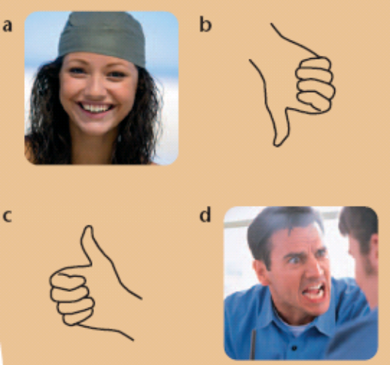
Wanna hand, Sid?
Can I help you?
- Your relationship
The two main types of language we use are formal and informal.

Informal language is the sort of language you use with a ______________________________.
Formal language is the sort of language you use with a _____________________________.

- Your reason for speaking

- Asking a workmate what time the team meeting is.
- Explaining a delayed time of departure to a customer.
- Telling a workmate about the type of music you like.

Which of the above is mainly to pass on information? __
Which is to find out information? __
Which is mainly to give an opinion? __

- Things that can cause problems
How would you tell the following people to stop work quickly in an emergency?
- a workmate who is wearing ear protectors
- a workmate who is speaking to a customer
- a workmate who is just learning English
- a workmate who is reversing a vehicle

Think of other work situations when it is difficult for others to understand you.

Tips for good communication
- Adapt your language and tone.
- Check the other person understands.
- Ask questions.
- Repeat information.
- Use open and positive body language.
- Notice the listener’s body language.
- Non-verbal messages

Which of these examples of body language is the most positive? What messages are they giving?

Speaking to people at work (Focus) 2:14

Task 1 (Audio 10)
Listen to an operative speaking to her workmate. What is the worker’s main purpose for speaking? Tick your answer.
Tip
There may be more than one purpose. Choose the main purpose.

__ To pass on information
__ To give an opinion
__ To ask for information
__ To reply to a question

Task 2 (Audio 11)
Discuss whether the following phrases are appropriate to say to a customer who is getting dangerously close to some closing doors. Tick the most appropriate speech bubble.

__ Oy! Watch it! The doors are closing.
__ You should be aware that while the doors are in the process of operating, it is highly dangerous.
Tip
- Very informal language would not be suitable.
- Choose the response that is polite and clear.

__ Be careful! You might catch yourself in the doors.

__ In the interest of safety please observe that the doors are closing at present.

__ Stand back, you idiot. You’re getting too close!

Task 3
Look at the picture of the customer who was getting dangerously close to the closing doors. What does his facial expression show? Tick your choice.

Tip
- Look carefully at the picture.
- Cross off the explanations that you think are not true first.
He is shocked. __
He is feeling sick. __
He is in pain. __
He doesn’t understand.__
He is upset. __
He is afraid. __
He is angry. __
He is happy. __
Speaking to people at work (Task) 2:15

Task 4
When you need to arrange a day off work you should do the following:
Tip
Choose the language that suits the relationship and purpose.
- speak to a colleague to check he or she can take over your shift
- speak to your supervisor to explain your absence.

- Pick out the phrases below that you could say to:
- colleague
I won’t be in tomorrow but Dave has offered to do my shift. __
- your supervisor.
Can you do me a favour? __

I hope that’s OK. __

Great one! Thanks. __
I’ll be back the day after tomorrow. __
You know I’d do the same for you. __

I’ve got permission. __
I’ll return the favour sometime. __

The boss said it’s OK. __

- You need a day off for a personal emergency. How would you explain this to your colleague or your supervisor? You can use any of the phrases above to help you, or you can make up your own.
Tip
Keep the speech short and use suitable language.

Task 5
Discuss with a partner what hand signals or gestures you would use to give the following urgent messages to people who can see you but can’t hear you.
- To tell a colleague working in a noisy area that he has an urgent phone call.
- To tell a forklift truck driver to stop immediately.
Tip
Try your ideas out on each other to see if the meaning is clear.
- To tell a colleague that it is safe to proceed.

